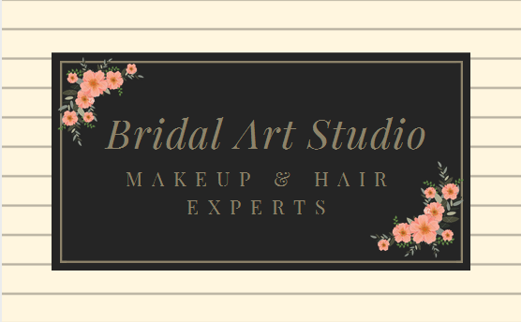

www.bridalartstudioinc.com

***Client Contract Agreement***

**THIS CONTRACT** is entered into on the ______ day of ____________, 20___ and is the only agreement between ___________________________________________ [hereinafter referred to as the “Client”] and Asra Khan

**BOOKINGS:** To secure a date, a signed contract is required with a determined deposit due at the time of signing. The deposit is non-refundable and non-transferable after three (3) days have elapsed from the date of contract signing. Please be advised, dates and scheduled makeup times will only be reserved when a signed contract and deposit are received.  ________ Initial  
  
**BOOKING TIMES:** Contract will contain a start time and end time initialed and approved by client. Each makeup application requires a certain length of time to be finished and is not to exceed time limit. When reserving your date, book accordingly. Any additional makeup needs outside contract will only be performed at the discretion of the makeup artist. All persons involved in makeup appointments need to be available at the scheduled time of said appointment in order to not break the contract. All makeup for more than one person must be at the same location and consecutive in time (no gaps in between).

**Early Call Times:** A $50 fee will be charged per artist for booked appointment times before 9:00 a.m. ________      Initial  
  
**DELAYS:** A late fee of $25.00 will be charged for every 15 minutes of delay when a client is late for the scheduled time, or if scheduled makeup exceeds allotted time because of client delays. Time consumed by hair not prepped or wet will cost additional $20 and up. We need to be notified about hair length and thickness as it consume more time then appointed therefore we need to add additional time to those hairstyles.  Contract will state the times late fees will begin and the amount charged and will be initialed and approved by client. ________ Initial

**TRAFFIC DELAY CLAUSE:** Due to Houston's potential accidents, construction or traffic delays, if any artist is not available for an appointed booking time, the appointments may be cancelled (at the sole discretion of the makeup artist) and all deposit money is refunded. Otherwise a later time frame can be provided as an option/alternate to be ready by,  not agreed upon contract below________ Initial

**SATISFACTION GUARANTEED:** Makeup will be completed to client's satisfaction, but is not to exceed allotted makeup time. Ample time is given for each makeup upon booking. Acceptance of completed makeup application by client is acknowledgement by client that makeup is done to his / her satisfaction. ________ Initial

**TRIAL MAKEUP:** A trial makeup (Consultation) is available for services. The trial makeup or hair service costs $75 per service and is limited to one (1) hour. The amount is due when trial service is rendered. If you are more than 15 minutes late for your appointment, it may be cancelled and a late fee of $25 will be applied to the final bill. Please call at least one (1) day in advance to reschedule a trial makeup. ________ Initial  
  
**CANCELLATION:** All deposit money paid by client will be refunded if contract is cancelled within three(3) days of contract signing. After the three day grace period, should a client cancel the booked event or any service on a contract, the deposit will not be refunded or transferred. If makeup artist cancels at any time or be unable to perform her duties for any reason, the deposit paid will be fully refunded within two (2) weeks. Client agrees that the refund of 100% of the deposit is the only liability to Bridal Art Studio and any and all of its owners, employees, and agents. ________ Initial  
  
**SERVICE LOCATION AND REQUIREMENTS:** Location of service for the day-of-event will be at the discretion of the client, but there are certain requirements the makeup artist needs to complete the makeup. A “set up” table/work area needs to be made available for the makeup artist at said location. Working electrical outlets must also be made available for use by makeup artist. Ample lighting, whether by means of natural light or by lamps, is necessary for services to be performed properly. We need assistance to carry equipment over stairs.  ________ Initial  
  
**PARKING FEES:** Where parking, valet or toll fees may be incurred; the amount will be included with the final bill and due for payment on the day of the event. _______Initial  
  
**TRAVEL FEE:** A fee will be charged for locations outside the studio. The amount will be determined at the time of inquiry. ________ Initial  
  
**AIRFARE AND ACCOMODATIONS:** All costs for travel to a booked event are to be paid by client. Costs may include, but are not limited to: airfare, hotel, transportation, parking, per diem, service incidentals and all taxes. ________ Initial  
  
**LIABILITY:** All brushes and makeup products are kept sanitary and are sanitized between every makeup application. Makeup products used are hypoallergenic. Any skin condition should be reported by the client to the makeup artist prior to application and, if need be, a sample test of makeup may be performed on the skin to test reaction. Client(s) agree to release the makeup artist Bridal Art Studio, its owners, and all employees and agents from liability for any skin complications due to allergic reactions. ________ Initial

**PET POLICY:** We love our pets, however due to sanitation and future clients unknown allergies and health risks, we cannot allow pets in the service area. They need to be kept in separate at all times the service is provided. ___________ Initial

**PAYMENT:** The final balance is due on the day of the event as one payment - no exceptions. The person(s) responsible for the entire balance of payment is the person(s) who has signed the booking contract. Acceptable forms of payment is only cash.________  Initial  
  
**SEVERABILITY:** If any provision or provisions of this Agreement shall be held to be invalid, illegal, unenforceable or in conflict with any of the law(s) of any jurisdiction, the validity, legality and enforceability of the remaining provisions shall not in any way be affected or impaired thereby. ________  Initial

**PHOTOGRAPHY:** This signed agreement serves as a release to client(s), photographer / videographer and authorizes them to release to Bridal Art Studio and its owners, agents, and employees any photographs / recordings to use on any promotional materials Bridal Art Studio deems necessary. _______Initial

Please note that no hair jewels or brooches are provided for hair styling. Please provide your own in order to achieve the desired hair style. You can provide you own makeup products for the application.  Bridal package can take up to 3 hours to complete. Party makeup can take 45 minutes and hairstyling can be 45 minutes to an hour depending on hair style and length. There is an extra charge for long, thick hair. There are additional charges to apply extensions and wet hair. We require dry straight hair. please notify us if anyone in your bridal party has thicker and longer hair than average as we may need additional time added to your appointment.

Please make sure you prepare your skin for makeup application. Get cleansing, exfoliation or facials if necessary. Also we don’t want freshly washed hair at the day of service. Please wash a day or two before. **We don't do blow dry for the hairstyles**. We use styling tools to achieve desired hair styles. All payments are due at the time of service, no holds or payment delays are offered or accepted. Feel free to reach us for any questions related to this. Thank you

**\*\*NO DEPOSITS MEANS NO APPOINTMENT IS CONFIRMED \*\***

***Therefore return contract as soon as possible to hold the desired date and time.***

Deposit options

* **Venmo**: @bridalartstudio or 7142691136
* **Facebook pay**: bridal art studio by Asra
* **Debit/credit card: Tax** will be applied.
* **Checks (in-advance only):** Payable to “Bridal Art Studio”
* **Cash** (receipt provided)

Make sure to schedule your appointment on our Facebook page to block desired time and date. This ensures us that we don't miss out any details on our calendar.

<https://www.facebook.com/Bridalartstudio/>

*You can fill this contract and return via text (7142691136), Facebook inbox or email (*[*bridalartstudio@gmail.com*](mailto:bridalartstudio@gmail.com)*)*

Make sure you are following us on our Facebook and Instagram and leave your feedback once you receive services. Also send us your professional pictures to be posted on our social media platforms.

**CLIENT’S NAME** ____________________________________

**CLIENT’S SIGNATURE** ______________________________

**TIME TO START_________________**

**TIME TO BE DONE________________**

**BRIDE(if applicable)**________________________________

**TOTAL NUMBER OF MAKEUP______________________**

**TOTAL NUMBER OF HAIR____________________________**

**TRAVELLING FEE _____________________________________**

**LOCATION_______________________________________-**

**ALLERGIES**__________________________________________

**TOTAL_______________________________________________**

**AMOUNT OF DEPOSIT**_____________________________

**AMOUNT DUE**________________________________________

**DATE OF MAKEUP APPLICATION**___________________________

**TODAY'S DATE**_______________________________________

______________________________________________________________________________

(Use this section for additional details or dates)

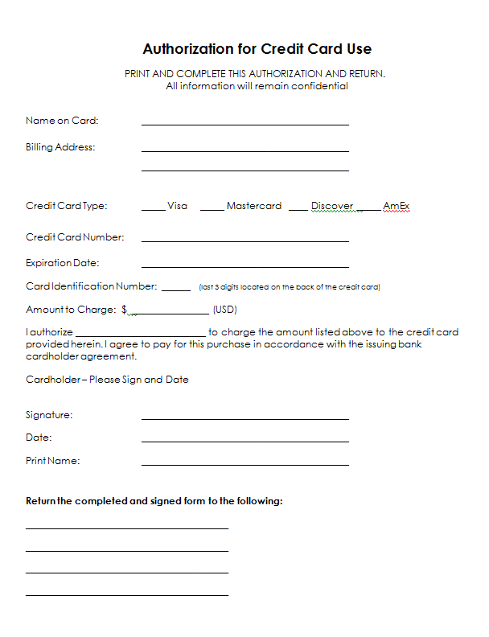

**Get Ready For your Event by Prepping Your Skin!**

The key to natural, flawless glowing skin begins with a fantastic skin preparation. Skin does not look its happiest when it is dry, tired, cracked or oily. If you prep the skin on your face correctly before you add your actual makeup, you will not need as much makeup to “fix” any given skin situation you might be faced with allowing an opportunity for your “natural, flawless glowing skin” to shine through!

**SKIN PREP**   
Begin with applying a toner on face and neck, followed by a moisturizing cream also applied to your face and neck. You need to assess whether or not your skin is oily or dry and find a face cream suitable for your specific skin type. One visit to a certified Esthetician would be more helpful than you realize, as most of us do not truly understand just exactly what our faces’ need. If your skin is “thirsty” you would need an intensive hydrating face cream, but if your skin is extra oily, you would need a face cream that is oil-free.

After toner is gently applied with a cotton pad, PRESS your face cream onto your face and neck, DO NOT rub and lather it onto face and neck. Pressing will ensure that you never break out from the pile up of too much cream and the pressing motion will bring back blood flow to the surface of the face giving you a natural, healthy glow!

Spray the entire face and neck with ROSE WATER or Evian Water Mist for extra hydration. The Rose water is a major factor in the appearance of that “natural, flawless glow” because whether your skin is oily or thirsty (a.k.a dry), the liquid mist hitting your moisturizer actually hydrates when it needs to and absorbs oiliness when it needs too. The water spray aids in melding the moisturizer into your skin rather than it just lying topically on the surface of your skin. This one step changes the course of how your skin looks once your makeup is applied. It’s the key ingredient to that “natural” glow.

After you spray the water mist liberally over face and neck, let skin dry naturally for a few minutes while you get dressed. This easy-to-do skin prepping routine makes the face look and feel hydrated and fresh and takes no more than 3 minutes from start to finish.

DON’T FORGET TO MOISTURIZE YOUR LIPS WITH ANY OIL OR YOUR FAVORITE BALM .VASELINE WORKS WELL AS WELL. Drink Plenty of water regardless…..

Please **DON’T** wash your hair on the day of the event. A day or two old hair work better to style.

***START THE PREP AS SOON AS YOU KNOW YOUR EVENT IS COMING UP!!!***